Laser  
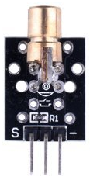

Overview  
 Lasers are light-emitting devices that are unique in emitting light that is both spatially and temporally “coherent,” which means they can cast over great distances while remaining narrow-beamed, and that they can emit light in a vary narrow spectrum (single-color) and in very short pulses. In a semiconductor laser such as this module, light is generated by radiative recombination of electrons and holes in a process known as stimulated emission, and amplified in the semiconductor material (which determines many of its physical properties, such as desired color). Since their invention in the 1960, lasers have found widespread applications ranging from surgery and manufacturing (where they act as cutting tools); optical drives, printers, and scanners (where along with a photocell they participate in emission/detection communication systems); range-finding and speed measuring devices; and lighting systems.

Because of its narrow focus, even relatively small amounts of laser light can lead to permanent eye injuries (burning of the retina) if a laser is pointed at or into your eye. While this risk is greater with higher power lasers than this module’s, **to avoid eye damage never look into a laser** or point one at someone else.

In this experiment, you’ll use your Raspberry Pi to blink the laser off and on, while simultaneously blinking an LED to provide simultaneous feedback.

Experimental Materials

Raspberry Pi x1

Breadboard x1

Laser x1

LED (3-pin) x1

Resistor(330Ω) x1

Dupont jumper wires

Experimental Procedure

1. If you have not done so already, prepare your development system by installing the Python interpreter, RPi.GPIO library, and wiringPi library as described in READ_ME_FIRST.TXT.
2. Install the laser module and three-pin LED on your breadboard, and use the resistor and Dupont jumper wires as illustrated in the Wiring Diagram below. Note you will connect only two of the three pins on the LED.
3. Execute the sample stored in this experiment’s subfolder.

If using C, compile and execute the C code:  
  
cd Code/C  
gcc laser.c -o laser.out –lwiringPi  
./laser.out

If using Python, launch the Python script:  
  
cd Code/Python  
python laser.py

1. Make experimental observations **as you take care to avoid looking directly into the laser or pointing the laser toward anyone’s eyes.** The laser and LED pulse on and off at the same time at one-second intervals.

Wiring Diagram

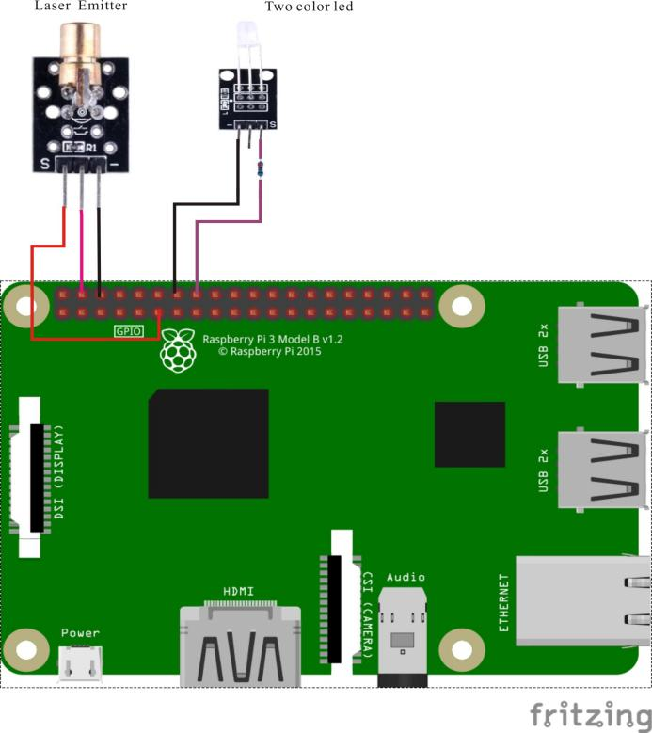

Laser pin position:

"S" ↔ Raspberry Pi pin 11

"+" ↔ Raspberry Pi +5V

"-" ↔ Raspberry Pi GND

LED pin position:

"S” ↔ Raspberry Pi pin 16 (through resistor)

"-" ↔ Raspberry Pi GND

Sample code

Python Code

#!/usr/bin/env python

import RPi.GPIO as GPIO

import time

LaserPin = 11 # pin11

LedPin = 16

def setup():

GPIO.setmode(GPIO.BOARD) # Numbers GPIOs by physical location

GPIO.setup(LaserPin, GPIO.OUT) # Set LaserPin's mode is output

GPIO.setup(LedPin, GPIO.OUT) # Set LedPin's mode is output

def loop():

while True:

print '...LaserPin on'

GPIO.output(LaserPin, GPIO.HIGH) # LaserPin on

GPIO.output(LedPin, GPIO.HIGH)

time.sleep(0.5)

print 'LaserPin off...'

GPIO.output(LaserPin, GPIO.LOW) # LaserPin off

GPIO.output(LedPin, GPIO.LOW)

time.sleep(0.5)

def destroy():

GPIO.output(LaserPin, GPIO.LOW) # LaserPin off

GPIO.cleanup() # Release resource

if __name__ == '__main__': # Program start from here

setup()

try:

loop()

except KeyboardInterrupt: # When 'Ctrl+C' is pressed, the child program destroy() will be executed.

destroy()

C Code

#include <wiringPi.h>

#include <stdio.h>

#define LaserPin 0

#define LedPin 4

int main(void)

{

if(wiringPiSetup() == -1)

{

printf("setup wiringPi failed !");

return -1;

}

pinMode(LaserPin, OUTPUT);

pinMode(LedPin, OUTPUT);

while(1)

{

digitalWrite(LaserPin, HIGH);

digitalWrite(LedPin, HIGH);

printf("Laser on....\n");

delay(1000);

digitalWrite(LaserPin, LOW);

digitalWrite(LedPin, LOW);

printf("Laser off....\n");

delay(1000);

}

return 0;

}

Technical Background

◆ Working voltage: 5V

◆ Specification: 15*24 mm  
◆ Light source wavelength: 650 nm

◆ Weight: 2.2 g  
◆ Includes a 10KΩ pull-up resistor connected to +5V.